24-1564

Resolution establishing absentee voting locations for the 2025 elections.

RESOLUTION

WHEREAS, voting is both a right and the vital core of a healthy democracy; and

WHEREAS, the goal of the La Crosse City Clerk's Office is that each eligible voter will be able to cast a ballot and have that ballot counted; and

WHEREAS, voting in person on election day or voting by mail may not necessarily be the best options for every voter; and

WHEREAS, in-person absentee voting is an option for voters prior to each election during the period prescribed by law with dates and times determined by the City Clerk; and

WHEREAS, it has been determined that having multiple in-person absentee voting sites may provide an opportunity for the City Clerk to expand in-person absentee voting hours and to make in-person absentee voting more accessible and equitable.

NOW, THEREFORE, BE IT RESOLVED by the Common Council of the City of
La Crosse that it hereby designates the following locations as in-person absentee voting sites that may be used for the 2025 elections with dates and times to be determined by the City Clerk:

La Crosse City Hall, 400 La Crosse St.
Southside Neighborhood Center,1300 6th St. S.
HMOOB Cultural and Community Agency, 1815 Ward Ave.
Cleary Alumni & Friends Center, 615 East Ave. N.

I, Nikki M. Elsen, certify that this resolution was duly and officially adopted by the Common Council of the City of La Crosse on January 9, 2025.
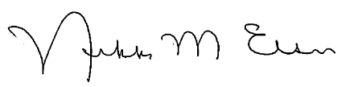
_______________________
Nikki M. Elsen, WCMC, City Clerk
City of La Crosse, Wisconsin

