24-1573

Resolution Approving Development Agreement and Sale Agreement with Glenside Park LLC (formerly Willow Grove LLC) for property at 1307 16th St S.

RESOLUTION

WHEREAS, the City of La Crosse declared certain property at 1307 16th St S, to be surplus property on February 8, 2024 via Resolution #24-0113; and

WHEREAS, the property was offered for sale through a Request for Proposals; and

WHEREAS, in June 2024, the Economic and Community Development Commission voted to approve the proposal from Willow Grove LLC (now known as Glenside Park LLC) via #24-0878 for the purchase and redevelopment of the property.
NOW, THEREFORE, BE IT RESOLVED by the Common Council of the City of La Crosse that it hereby approves the attached Development Agreement and Sale Agreement with Glenside Park LLC.

BE IT FURTHER RESOLVED that the proceeds from this sale will be deposited to General Revenue – Sale of Land.

BE IT FURTHER RESOLVED that the Mayor and City Clerk are authorized to sign any related documents.

BE IT FURTHER RESOLVED that the Director of Finance and Director of Planning, Development, and Assessment is hereby authorized to take any and all steps necessary to effectuate said resolution.

I, Nikki M. Elsen, certify that this resolution was duly and officially adopted by the Common Council of the City of La Crosse on January 9, 2025.
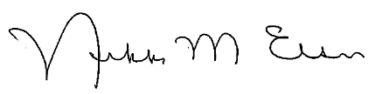
_______________________
Nikki M. Elsen, WCMC, City Clerk
City of La Crosse, Wisconsin

