Resolution approving Certified Survey Map - Block 4 of St. Paul's First Addition to the City of La Crosse and Parts of the NE-NW and NW-NW of Section 20, T16N, R7W, City of La Crosse, La Crosse County, Wisconsin and request for approval of an easement for existing sewer utility line currently within the City-owned property.

RESOLUTION

BE IT RESOLVED by the Common Council of the City of La Crosse that it hereby approves the Certified Survey Map - Block 4 of St. Paul's First Addition to the City of La Crosse and Parts of the NE-NW and NW-NW of Section 20, T16N, R7W, City of La Crosse, La Crosse County, Wisconsin and request for approval of an easement for existing sewer utility line currently within the City-owned property.

I, Nikki M. Elsen, certify that this resolution was duly and officially adopted by the Common Council of the City of La Crosse on January 9, 2025.
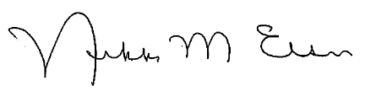
_______________________
Nikki M. Elsen, WCMC, City Clerk
City of La Crosse, Wisconsin

