24-1562
Proposed Amendment for J&A 1.2.2025

Amended Resolution amending Council Rule II(6) regarding public information presentations.

AMENDED RESOLUTION

BE IT RESOLVED by the Common Council of the City of La Crosse that Council Rule II(6) is hereby amended to read as follows:

Rule II: Meetings.

(6) Public Information Presentations. From time to time, the City may desire to host a public information presentation. A possible quorum of the Council (and other governing bodies) may attend; however, no deliberation or action may occur. Public information sessions shall not include pending legislative matters. Pending legislative matters shall proceed through the regular legislative process and be noticed accordingly.

I, Nikki M. Elsen, certify that this resolution was duly and officially adopted by the Common Council of the City of La Crosse on January 9, 2025.
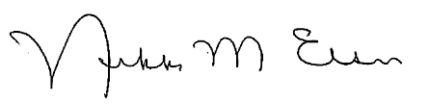
_______________________
Nikki M. Elsen, WCMC, City Clerk
City of La Crosse, Wisconsin

